**Harvard Forest**

latest GAMM results (we think we have the structure right, no DBH for now):  
[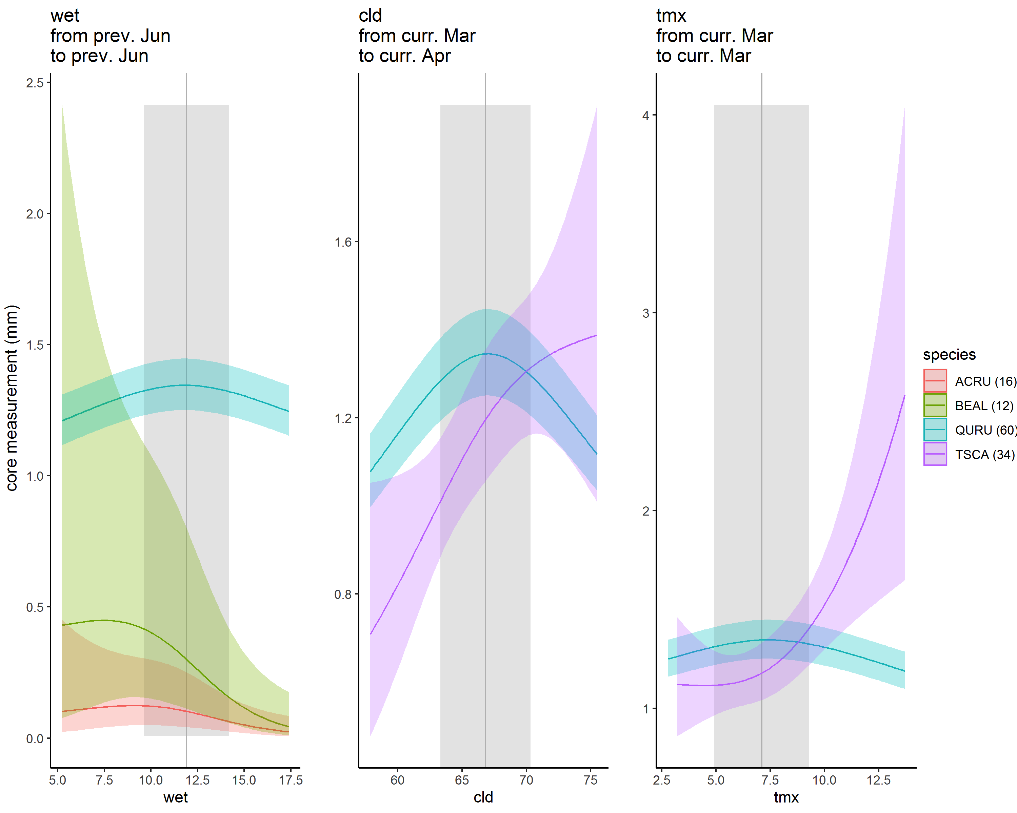](https://user-images.githubusercontent.com/6355854/82467247-79a3cc00-9a8f-11ea-941c-786a739b2bb6.png)  
vertical bars show mean +/- 1 SD for climate variable.

**response to previous June moisture**- *not sure if this makes sense* - It's a unimodal response in climwin and for most abundant species (QURU) in latest GAMM. I'm surprised that this comes out. It's also strange how there's not a patch of time windows with similar responses surrounding it, as tends to be the case at other sites.*  
[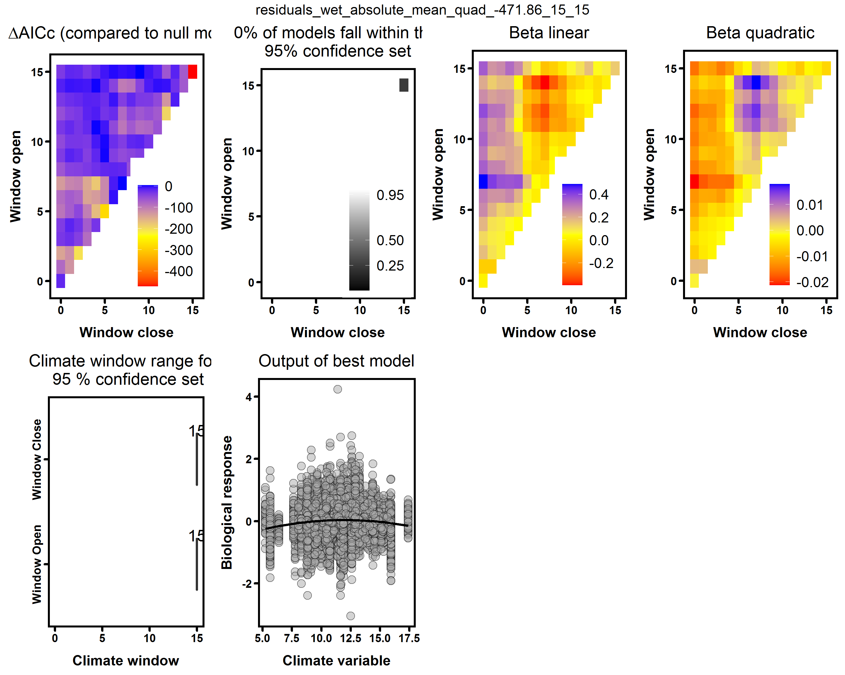](https://user-images.githubusercontent.com/6355854/82468430-c8059a80-9a90-11ea-8a46-37324bcdf491.png)

**March to April cloud response** - *hmmm....* - that would be late spring, maybe affecting spring phenology?? QURU dominates numerically and matches climwin, TSCA apparently likes cloudy springs?? Again, it's also strange how there's not a patch of time windows with similar responses surrounding it, as tends to be the case at other sites.  
[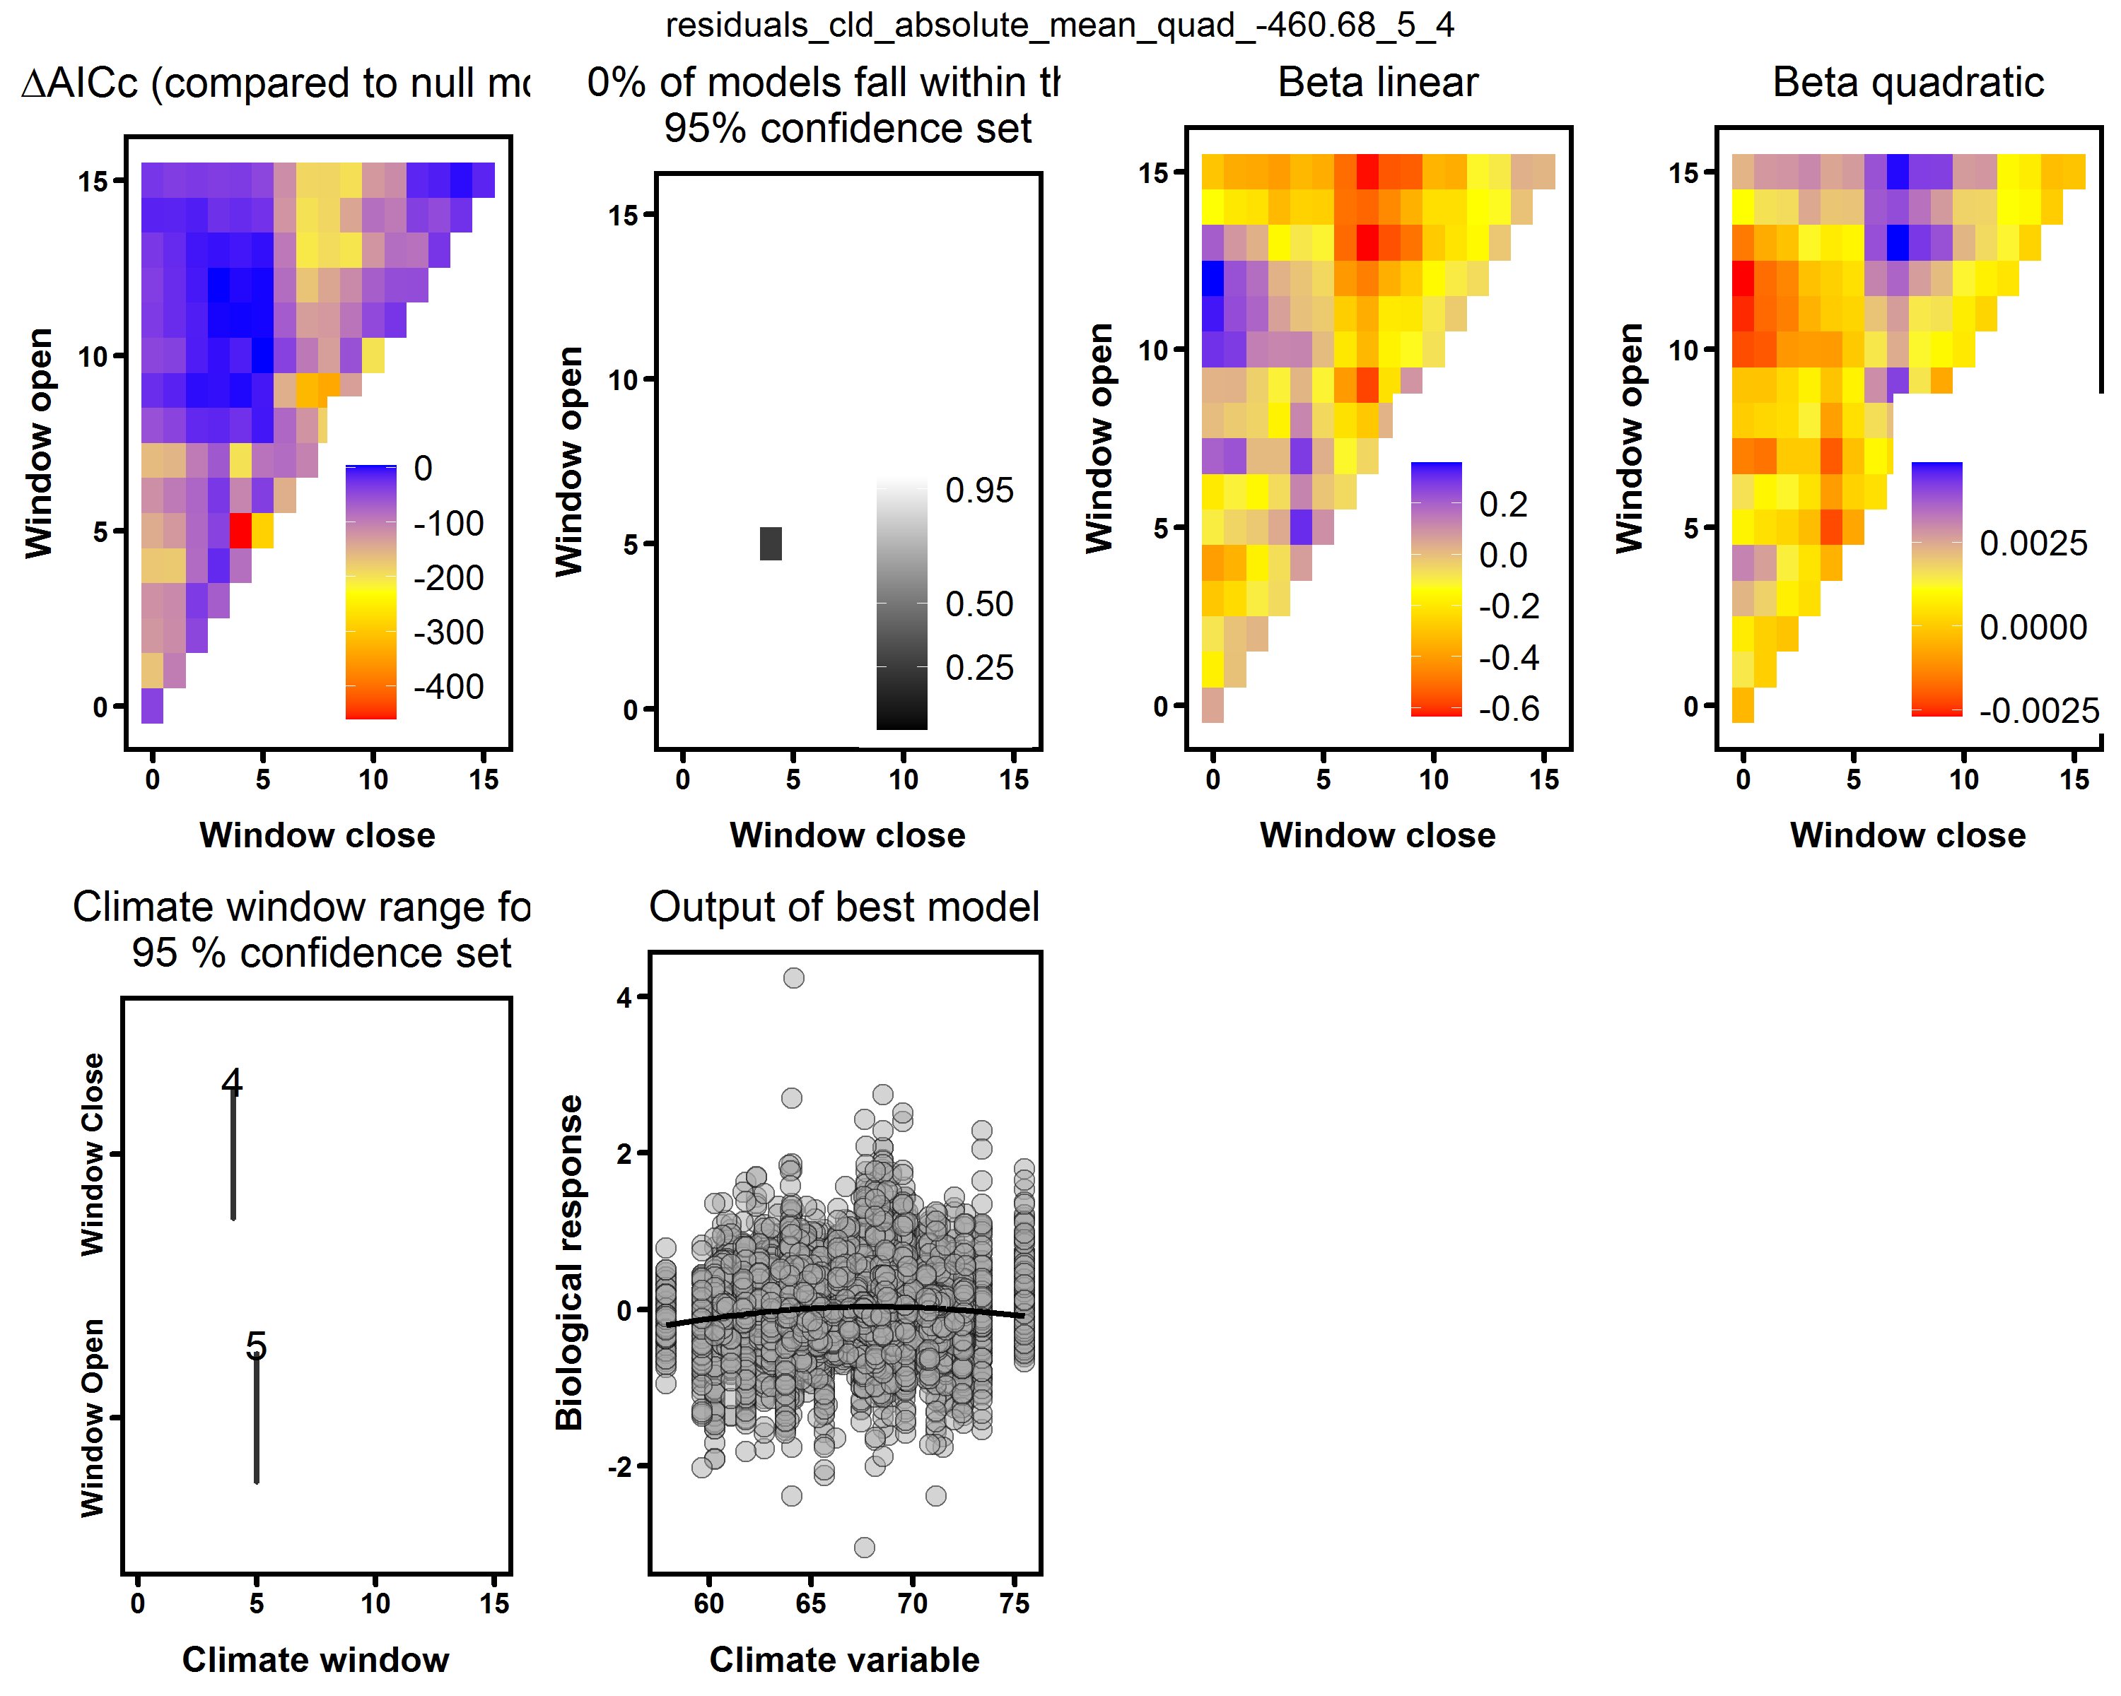](https://user-images.githubusercontent.com/6355854/82469032-7e697f80-9a91-11ea-96f5-77535d14497c.png)

**March T_max response** - *hmmm....* - that would be late spring, maybe affecting spring phenology?? QURU dominates numerically and matches climwin, TSCA likes warm March (believable). Again, it's also strange how there's not a patch of time windows with similar responses surrounding it, as tends to be the case at other sites.  
[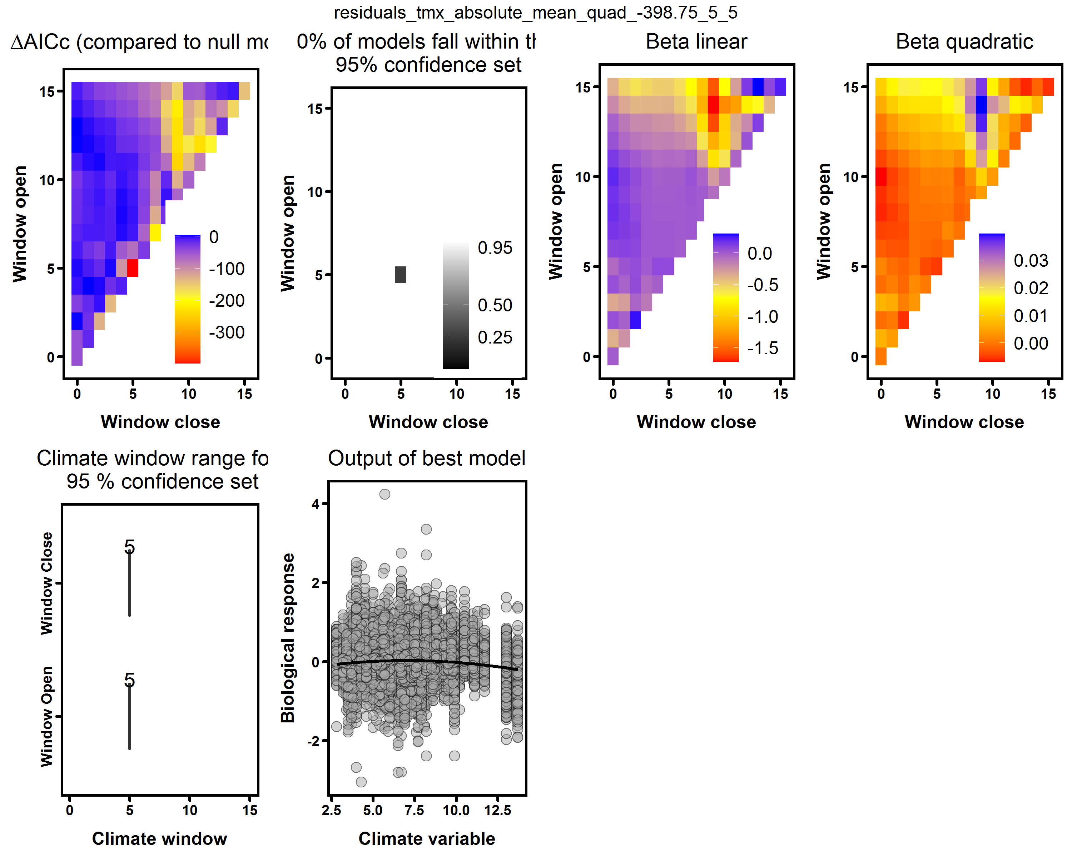](https://user-images.githubusercontent.com/6355854/82469990-c2a94f80-9a92-11ea-840a-ed51ec47a807.png)

*bottom line--I don't see any major problems/ inconsistencies, but the relationships/ variables identified surprise me. I'd like to get input from Neil and* [*@crollinson*](https://github.com/crollinson) *as to whether these make sense.*